(Approx. 431 words)

QuickMonth Calendar
By Ken Peters, Product Review, Hilton Head Island Computer Club, South Carolina
http://hhicc.org
product.review (at) hhicc.org

This article has been obtained from APCUG with the author’s permission for publication by APCUG member groups; all other uses require the permission of the author (see e-mail address above).

If you’re tired of double clicking the clock to get the calendar up, then this program is for
you. http://www.codedawn.com/qmc/quickmonth-calendar-download/

QuickMonth Calendar is a freeware program which displays a small popup calendar on
your Windows desktop whenever your mouse hovers over the clock in the system tray. The calendar display may also be toggled on and off by using the Windows+Q keyboard shortcut. The program works with XP and Windows 2000. Click the clock once to make it appear. Vista already has a popup calendar.
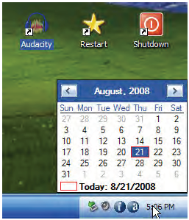
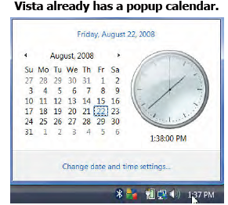

You can get QuickMonth Calendar by visiting the download page. QuickMonth Calendar
is free and does not include any adware or spyware.

NOTE: Some antivirus programs have incorrectly detected QuickMonth Calendar as a
Trojan horse. Do not be alarmed — this type of erroneous detection is called a false positive. If you receive a virus warning message regarding QuickMonth Calendar (qmc.exe), please report the false positive to your antivirus software manufacturer so they can update their definitions. Here are a few of QuickMonth Calendar’s features:

To quickly jump to today’s date, right-click on the calendar or left-click the bottom of
the calendar where it says “Today.” Use the buttons at the top of the calendar to change the month. You can also left-click on the name of the month to see a popup menu of all the months (see Example 1).

Left-click on the year to quickly change the year (see Example 2).

The calendar automatically detects the location of your Windows taskbar, so if
you move the taskbar to the top, left, or right side of the screen, the calendar will
still display next to your system tray clock (you may have to restart Windows once
for the change to take effect).

The look of the calendar changes according to what your system colors are
(as determined by your current Windows theme or visual style). The calendar will appear in any program when you put the pointer over the clock. I have found this program very handy when trying to find a date when writing an email or other document. When I need to look up a date, it’s very nice to have the calendar popup just by hovering the pointer over the clock. It’s also helpful when on the telephone
and trying to settle on a date.

